Name: Vivek Lele

Roll No: 23MCA1023

Q1. **Exercise 1:**

Write a program that takes two numbers (data type: Double) as input from the user using the Scanner class.

Calculate and print the sum of these two numbers.

**Test Input:**

Enter the first number: 8.7

Enter the second number: 3.2

**Test Output:**

Sum of the two numbers: 11.9

**Code:**

import java.util.Scanner;

import java.io.*;

class Sum{

public static void main(String[] args){

Scanner sc = new Scanner(System.in);

System.out.println("Enter first number: ");

double num1 = sc.nextDouble();

System.out.println("Enter second number: ");

double num2 = sc.nextDouble();

double sum = num1 + num2;

System.out.println(sum);

}

}

**Output:**



Q2. **Exercise 2:**

Write a program that takes two numbers (data type: Int) as input from the user using the Scanner class.

Calculate and print the sum of these two numbers.

System.out.println("Sum of the two numbers: " + sum);

// Close the scanner to avoid resource leaks

scanner.close();

}

}

**Test Input:**

Enter the first number: 25

Enter the second number: 13

**Test Output:**

Sum of the two numbers: 38

**Code:**

import java.util.Scanner;

import java.io.*;

class Sum{

public static void main(String[] args){

Scanner sc = new Scanner(System.in);

System.out.print("Enter first number: ");

int num1 = sc.nextInt();

System.out.println("Enter second number: ");

int num2 = sc.nextInt();

int sum = num1 + num2;

System.out.println(sum);

}

}

**Outptut:**

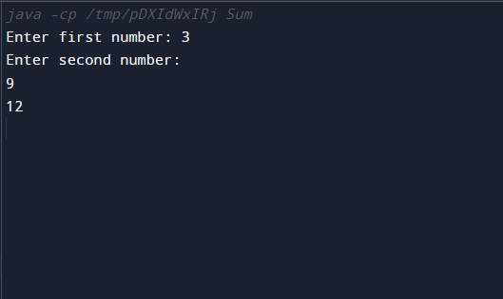

**Q3. Create a program that includes the following methods:**

**int getInput(String prompt): This method takes a prompt as a parameter, prints the prompt, and then reads an integer input from the user.**

**Code:**

import java.util.Scanner;

class HelloWorld {

public static void main(String[] args)

int num1 = getInput("Enter the first number: ");

int num2 = getInput("Enter the second number: ");

int result = calculateSum(num1, num2);

displayResult(result);

}

static int getInput(String prompt) {

System.out.println(prompt);

Scanner sc = new Scanner(System.in);

int i = sc.nextInt();

return i;

static int calculateSum(int num1, int num2) {

return num1 + num2;

}

static void displayResult(int result) {

System.out.println("The result is: " + result);

}

}

**Output:**

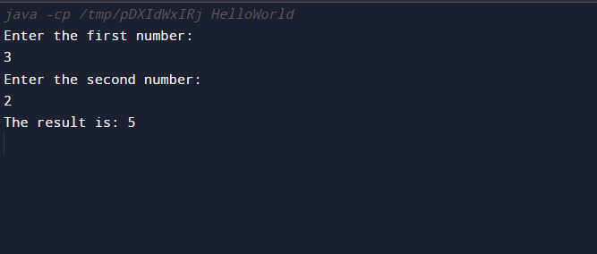

**Q4. Exercise Question 4:**

* **Create a Java class named Calculator with the following attributes:**

**None**

* **Implement a method named multiply that takes two integers as parameters, multiplies them, and prints the result.**
* **Create an object of the Calculator class in the main method, and use it to call the multiply method with two integer values.**

**Test input:**

Integer 1: 8

Integer 2: 4

**Test Output:**

Result of multiplication: 32

**Code:**

import java.util.Scanner;

public class Calculator {

public void multiply(int num1, int num2) {

int result = num1 * num2;

System.out.println("The result is: " + result);

}

public static void main(String[] args) {

Calculator calculator = new Calculator();

calculator.multiply(5, 10);

}

}

**Output:**

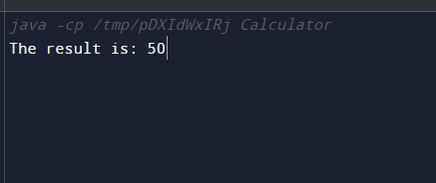

**Q5.**

Create a Java class named Calculator with the following attributes:

Two integer attributes named number1 and number2.

Implement a method named assignValues that takes two integers as parameters and assigns them to the number1 and number2 attributes.

Implement another method named multiply that multiplies the values of number1 and number2 and prints the result.

Create an object of the Calculator class in the main method, use the assignValues method to set values for number1 and number2, and then call the multiply method.

**Test Input:**

**Values assigned: Number1 = 6, Number2 = 5**

**Test Output:**

**Result of multiplication: 30**

**Code:**

import java.util.Scanner;

public class Calculator {

private int number1;

private int number2;

public void assignValues(int num1, int num2) {

number1 = num1;

number2 = num2;

}

public void multiply() {

int result = number1 * number2;

System.out.println("Result of multiplication: " + result);

}

public static void main(String[] args) {

Calculator calculator = new Calculator();

calculator.assignValues(6, 5);

calculator.multiply();

}

}

**Output:**

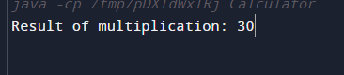

**Q6. Exercise Question:6**

Create a Java class named Calculator with the following attributes:

Two integer attributes named number1 and number2.

Implement a method named assignValues that takes two integers as parameters and assigns them to the number1 and number2 attributes using the this keyword.

Implement another method named multiply that multiplies the values of number1 and number2 and prints the result.

Create an object of the Calculator class in the main method, use the assignValues method to set values for number1 and number2, and then call the multiply method.

Input:

Values assigned: Number1 = 9, Number2 = 7

Output:

Result of multiplication: 63

**Code:**

**import java.util.Scanner;**

**public class Calculator {**

**private int number1;**

**private int number2;**

**public void assignValues(int num1, int num2) {**

**this.number1 = num1;**

**this.number2 = num2;**

**}**

**public void multiply() {**

**int result = this.number1 *this. number2;**

**System.out.println("Result of multiplication: " + result);**

**}**

**public static void main(String[] args) {**

**Calculator calculator = new Calculator();**

**calculator.assignValues(9, 7);**

**calculator.multiply();**

**}**

**}**

**Output:**

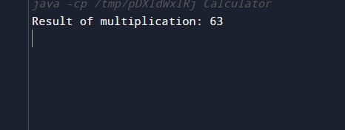

**Q7. Exercise Question 7:**

**Problem Statement:**

Create a Java class named Circle with the following attributes:

radius (double)

Implement methods to:

Set the radius of the circle (setRadius(double radius)).

Calculate and return the area of the circle (calculateArea()).

Calculate and return the circumference of the circle (calculateCircumference()).

Display the details of the circle (displayDetails()).

Create an object of the Circle class in the main method, set its radius, and then invoke the methods to display the details, area, and circumference of the circle.

**Test Input:**

7.5

**Test Output:**

Circle Details:

Radius: 7.5

Area: 176.71458676442586

Circumference: 47.12388980384689

**Code:**

**import java.util.Scanner;**

**public class Main {**

**public static void main(String[] args) {**

**Circle circle = new Circle();**

**circle.setRadius(7.5);**

**circle.displayDetails();**

**}**

**}**

**class Circle {**

**private double radius;**

**public void setRadius(double radius) {**

**this.radius = radius;**

**}**

**public double calculateArea() {**

**return Math.PI * radius * radius;**

**}**

**public double calculateCircumference() {**

**return 2 * Math.PI * radius;**

**}**

**public void displayDetails() {**

**System.out.println("Circle Details:");**

**System.out.println("Radius: " + radius);**

**System.out.println("Area: " + calculateArea());**

**System.out.println("Circumference: " + calculateCircumference());**

**}**

**}**

**Output:**

